Final Project

Please find my final code on [GitHub](https://github.com/peleonard/CMPS-4720-6720-Sp18/blob/master/project/s2s0418testIMAC.py).

The training output is very long, as this is a deep learning task. Following is a screenshot of a part of it. The loss function can be treated as a cross-entropy function.

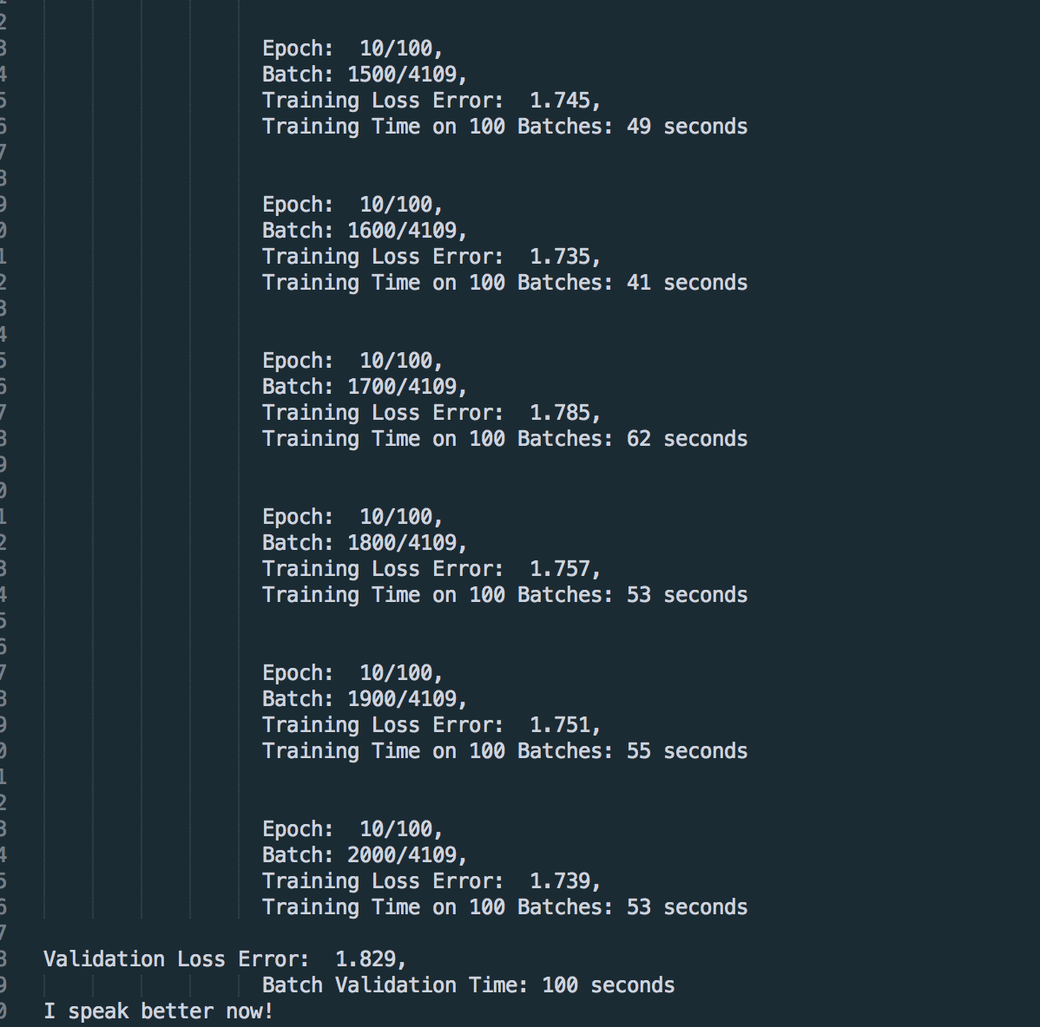

The screenshot below is the testing result, i.e. how I “chat” with this chatbot.

We observed that the result is somehow reasonable, but still need more training. By the way, thanks to Google Colab, I am able to train 14 epochs. I assume with more epochs, we can get smaller validation error, thus more human-like answers.

